Electronics Lesson 6

**Overview**

In this lesson students will learn how create a motion detector.

Plan

1. Ultrasonic Sensor
2. Activity: Motion Sensor
3. Free Play

Big Concept #1: Ultrasonic Sensor

Instructor: The Ultrasonic Sensor sends out a high-frequency sound pulse and then times how long it takes for the echo of the sound to reflect back. The sensor has 2 openings on its front. One opening transmits ultrasonic waves, (like a tiny speaker), the other receives them, (like a tiny microphone).

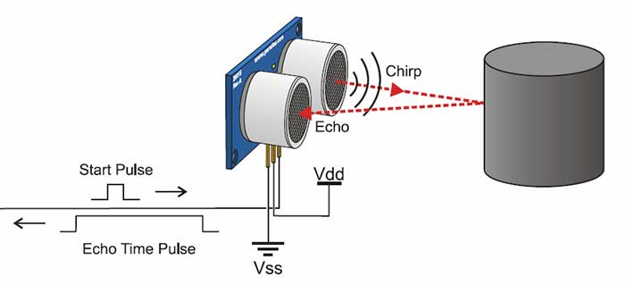

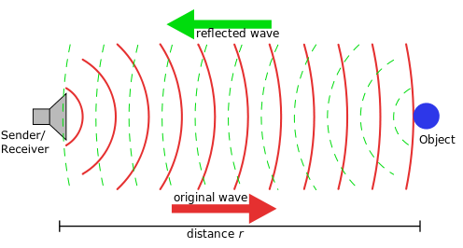

To students: Can anyone give me examples where you can use this ultrasonic sensor?

Expected Answer: Home security systems, detecting a baby in a mother’s stomach…

Instructor: Show class ultrasonic sensor. There are 4 pins. First pin is to receive electricity. Second pin is to send the ultrasonic wave. Third pin is to listen for the ultrasonic wave. Fourth pin is for ground.

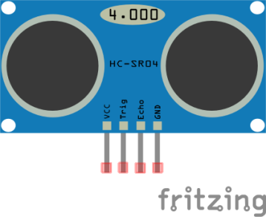

Activity 1: Motion Detector

Setup computers. Distribute worksheets and download code, if no worksheets write the code on the board.

1. Have students fill in the blank

Expected Answer:

Layout:

Note: buzzer can be switched out with a red led.

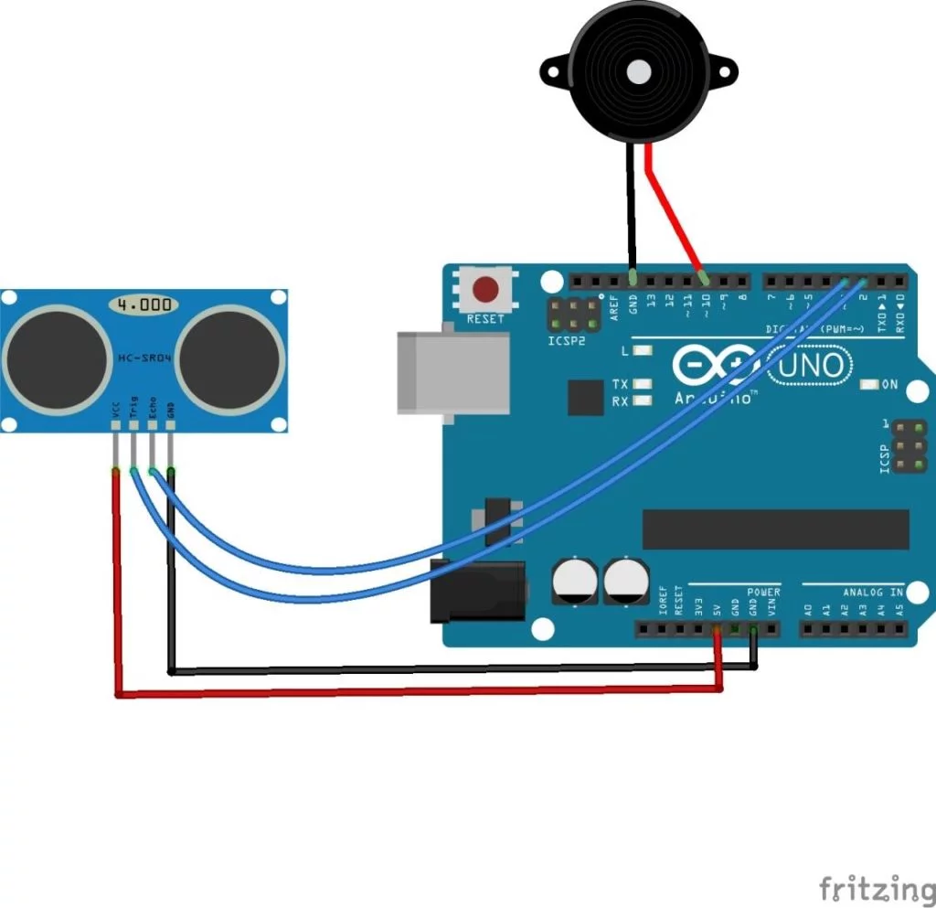

Code:

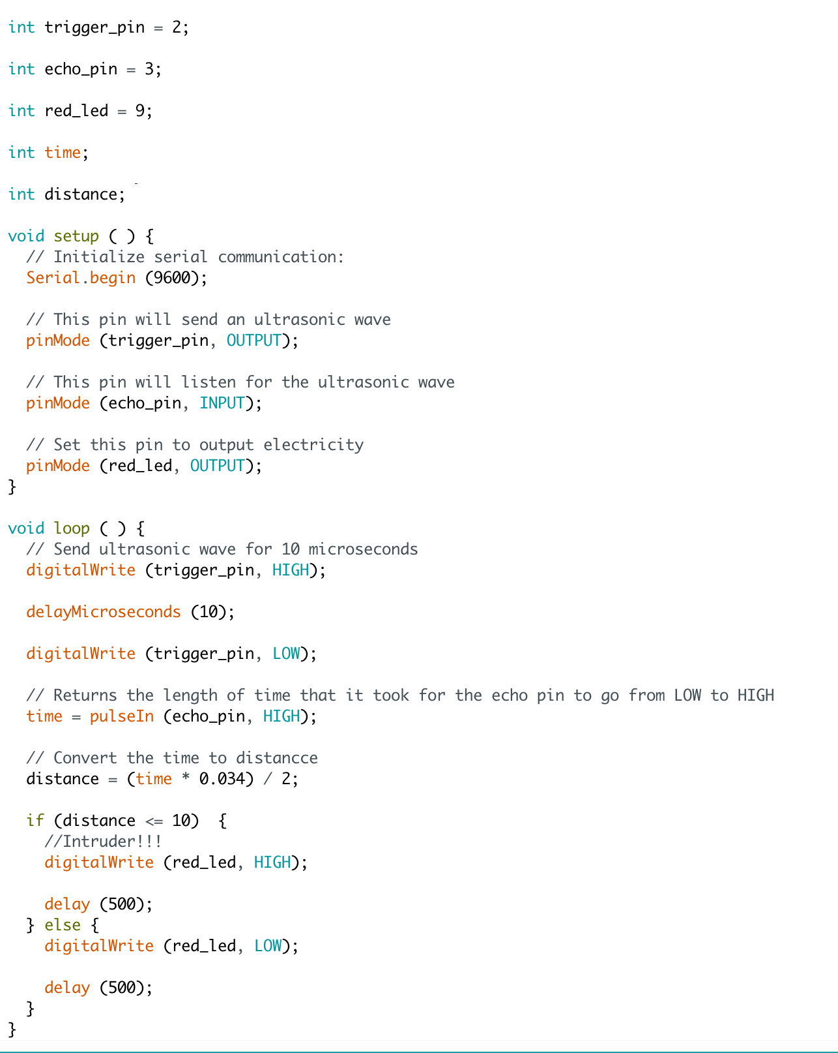

Big Concept #2: Free Play

Instructor: Use your imagination and what you learned from the last six classes to build something!